360 Degree Flexible Drilling Machine
Drill machines have been the heart of every industry. Drilling holes in parts, sheets and structures is a regular industrial work. Perfect and well aligned drilling needs fixed and strong drills. Some parts cannot be drilled using fixed drills due to low space between drill bit and drill bed. We need to use hand drills in such cases but hand drills have alignment problems while drilling. So here we propose a 360 degree flexible drill that can be mounted on a table or wall and can be used to drill holes horizontally, vertically or even upside down. So this makes it possible for easy drilling in even complicated parts and surfaces. Thus we use rotating hinges and connectors with motor mount and supporting structure to design and fabricate a mini 360 degree drill for easy drilling operations.
Block Diagram :
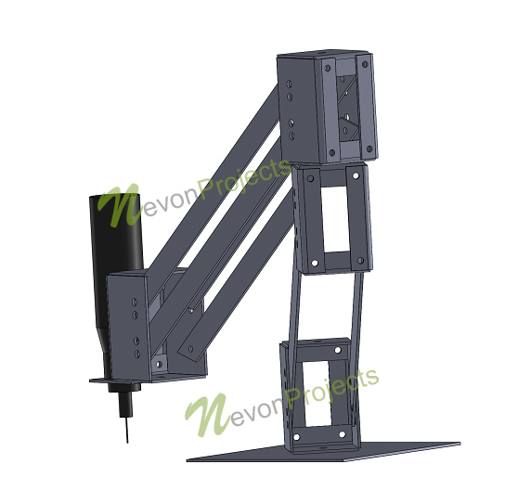
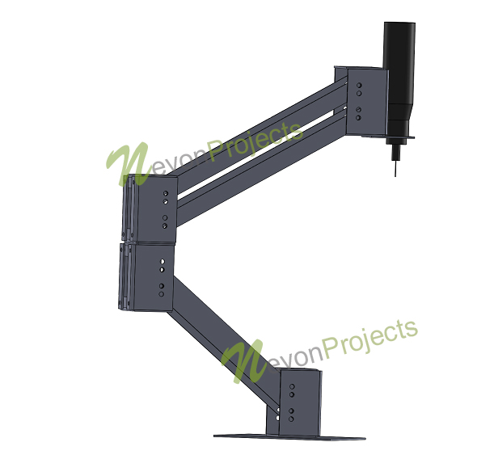
Components :
- Motor
- Bit
- Connecting arms
- Hinges
- Wall/Table Mount
- Supporting Frame
- Joints & Screws
Advantages:
- Efficient Drilling
- 360 Degree Rotation

